

**Java Hunter (Java Assistance Game with Assessments)**

**For Davao City National High School**

A Course Requirement for

IS 311/L System Analysis and Design

Members:

Karl Dame Angelo S. Abad

Umut Burkut

Cris B. Maloloy-on

Abdurrahman Samgar

Prof. Fe Yara

Instructor

October 16, 2018

**TABLE OF CONTENTS**

**List of Figures**……………………………………………………………….4

**Chapter 1-The Company**…………………….………..………………..….6

Company Profile…...………………………………………………….6

Vision………………………………………………………...…………7

Mission……………………………………………...………………….7

Goals……………………………………………………………………8

Organization Chart………………………………...………………….9

Game Environment………………………………………………….10

Game Design……………………………………...……………..…..12

Game Flow Diagram…………………………...……………………15

**Chapter 2-The Proposal**………………………………………………….17

Statement of the Problem……………………………..……………17

System Objectives……………………………………..……………19

Feasibility Study………………………………………..……………20

Schedule…………………………………………...…………………22

**Chapter 3-The Solution**………………………………….………………..23

Functional Requirements……………………………..…………….23

Process Flow…………………………………………..…………….25

Game Prototype……………………………………..………………26

**Chapter 4-The implementation**………………….….………..………….32

User Acceptance Training………………….……….……………...32

Deployment Plan………………………………………...…………..35

User Manual……………………………………...…………………..37

**Chapter 5-Source Codes**………………..……..………….……………..39

**References**…………………………………………………...……………..53

**Appendices**………………………………………………………………....54

1. Letter to the Company…………………………………………..54
2. Survey and Interview Questionnaire…………………………...57
3. Letter to the Consultant………………………………………….62
4. Rubric……………………………………………………………..63
5. Curriculum Vitae………………………………………………….69
6. Certificates………………………………………………………..74

**LIST OF FIGURES**

Figure 1. Organizational Chart……………………………………………………..9

Figure 2. Game Flow Diagram………………………………………….………..15

Figure 3. Schedule…………………………………………………………………22

Figure 4. Process Flow……………………………………………………………25

Figure 5. Main Menu……………………………………………………….………26

Figure 6. Settings…………………………………………………………………..26

Figure 7. Scoreboard………………………………………………………………27

Figure 8. New Game………………………………………………………………27

Figure 9. Character Selection…………………………………………………….28

Figure 10. Instructions…………………………………………………………….28

Figure 11. Pop-up Lessons……………………………………………………….29

Figure 12. Enemy Spawn…………………………………………………………29

Figure 13. Assessment/Puzzle…………………………………………………...30

Figure 14. Discussion with the Teacher…………………………………………32

Figure 15. Showing of game functionality……………………………………….32

Figure 16. Successful user training………………………………………………33

Figure 17. Certificate of acceptance……………………………………………..33

Figure 18. Deployment Planning…………………………………………………34

Figure 19. Deployment…………………………………………………………….35

Figure 20. Successful Deployment………………………………………………35

Figure 21. Certificate of Deployment…………………………………………….36

Figure 22. New Game Manual……………………………………………………36

Figure 23. Character Selection Manual………………………………………….37

Figure 24. Assessment Manual…………………………………………………..38

**Chapter 1**

**THE COMPANY**

**Company Profile**

Davao City National High School was founded in 1922. It was first known as Davao Provincial High School. It was first housed in a nipa hut located at Magallanes Street. The number of the first students enrolled were just 67, while the OIC was Mr. Dominador Fernandez and the Principal was Mr. Adolfo Casolan. They had 3 teachers in their first year of serving. After Davao City became a chartered city, the name of the school was changed to Davao City High School. The people in charge wanted to accommodate the increasing numbers of enrollees so, they built a building in its present site in 1941. Unfortunately, it was demolished become of American Bombs in World War 2 in 1945.

After the war, classes were resumed and temporarily held at the Chavez Building in Claveria Street. It was later moved to Villa Abrille Street in 1946, this site is more spacious and accommodating. In 1950, Davao City High School was finally transferred to its present location, Florentino Torres Street with the area of Sixty-Two Thousand Six Hundred Fifty-seven square meters. The lot was donated by the Tionko Family which was a very rich and influential family. Davao City High School became Davao City National High School because of the nationalization of all secondary schools in the Philippines.

Today, Davao City National High School is now 81 years old. It has acquired 36 buildings and some facilities for education which includes; an Auditorium, Library, Learning Centers, Rizal Shrine, Heroes Tree Park, and Mini Gardens. Also, new comfort rooms were added to improve the school facilities and to satisfy student needs. The school has 450 employees including teachers, utility employees, and officials today. The student population has more than 13,000 students because of the addition of the senior high population.

Davao City National High School offers quality education and support to students that go to the school. Mrs. Victorina B. Jacinto, the present principal in the school, helped make a lot of improvements for the school. She is keen on implementing the ICT program to help students learn hands-on computer activities.

**Vision**

The school envisions to harness the best of the Filipino Youth through quality education imbued with values and relevant academic and non-academic preparations in-order to attain peace, just and development for GOD, Country and People.

**Mission**

Davao City National High School endeavors to cater to the needs of the community for basic education in preparing the youth for global competitiveness through the search of the National Culture of Excellence, thus, making it as the center for community transformation.

**Goals**

Davao City National High School is a public secondary institution which provides a system:

1. Where education will be characterized by active learning

2. Where education provides opportunities for service learning - where students are exposed to real world problems and realities and instill in them the desire to work for the common good; and

3. That helps individual become capable of adapting to a changing world.

**Organization Chart**

Mrs. Victorina Jacinto

Principal

Mrs. Milagros S. Novabos

DNCHS TEWA President

Mr. Emmanuel Alpha Sicam

ICT Program Head

Mrs. Annabelle P. Ornopia

Programming Head

Figure 1: Organizational Chart

**Principal**

The Principal is the head of all operations of the school. She inspects all the transactions happening before it could go through and proceed. She makes sure that the school is well managed and all the school processes are properly done. She is the one who has the say to almost anything regarding the school.

**President**

The president is the one who handles the school's operations that went through the principal. She is the one tasked to manage the transactions that involves the schools. She is the one who handles the business end of the school.

**ICT Program Head**

The ICT Program Head is the one task to handle the ICT Program of the school. He is the one who manages the system of the school also. He also teaches the students enrolled in the program. He is the one tasked to improve the system and the services the program offers.

**Programming Head**

She is the one tasked to handle all the programming classes for senior high school. She is also their programming teacher. She is the one who prepares all the lessons and assessments for the senior high students taking the programming classes.

**Game Environment**

**Story**

The game has no dialogues to follow for a story line but the main objective/story of the game is to kill all the enemies for bonus points, read all the guides for the lessons, and answer all the assessments correctly.

Components

* Graphics – The game will have a wise design and graphics so that users can use it using a not so powerful pc.
* Story-line – It will have a story-line which the user can go through each level by completing a programming task
* Challenging levels – Each level is getting more and more challenging in-order to help the user develop his/her skill in programming
* Knowledgeable tasks – All the tasks or quests are very interesting because it will challenge the skills of the user in java programming. It will also help them develop more skills.

**Scope and Limitations**

The game is basically about java programming so it will cover the fundamentals of java. It includes selection structures and iteration. Advanced UI is not included in the game because the students are still learning the basics of java and the developers do not want to disrupt their learning process. To be exact, the topics included are if, if-else, if-elseif, switch, while loop, do while loop, and for loop.

**Features**

Saving Game

This feature will allow the students to save their activity when they want to stop playing or their session ends. This feature will help them store their data in-order to be loaded next session of their classes. They can use this feature if they do not know what to do anymore with the quest, they can just save and study the topic included in the quest they go back again.

Loading Game

This is the feature that they will need when they want to load their previous game or if they want to finish their unfinished business with the game. They can use this if they saved a game progress.

Scoring System

The game will have a scoring system which will give incentives to the students that will finish the assessments in each level. They will get points that will accumulate until the game is finally finished. Every completed puzzle in the first try is worth 100 points. Every failed answer is a -15 to the 100 points that should be given.

**Game Design**

Characters

The game has 2 characters where users can choose from. Shinbi and Countess. They are both female characters from paragon assets. The users will choose from them and use them to play the game. These two characters have different skills and abilities.

Chapters and Levels

The game is designed to have 2 chapters composed of two Java topics that are included in the game. These topics are about Selection structures and Iteration. Each chapter will have levels to be accomplished in-order to progress to another chapter. There will be 3 levels per chapter of the game. Each level will have the different difficulty so that students will also progress in learning the topics. Each level has its own assessments that will help the user progress through the game. The only way to finish the game is to answer all assessments in each level.

* Map
  + The game will be played in different maps. Each level has different maps. But the levels are from the same assets.
* Chapter 1
  + Chapter one is all about selection structures of java. It is composed of if, if-else, and switch lessons and assessments. There will be enemies also that will spawn along the way.
* Chapter 2
  + Chapter two is about Iteration. The topics included in this chapter are while loop, do-while loop, and for loop. There will be pop-ups of lessons and examples in each level and also there will be enemies and assessments.
* Level 1, 2, and 3 of all chapters will be played in the same region as the chapter but in different islands or terrains. The only way to finish the level is to complete all assessments inside it.

Assessments

All assessments in the game will be in a form of fill-in-the-blanks. The students need to figure out the output of the syntax in the puzzle. Completing the puzzle is the only way to advance to the next island or level. The developers will provide 18 different assessments for the chapters so that the teacher can choose any assessment they want to use. This puzzle is a java program involving the topic designated for the chapter. The assessments increase in difficulty as the player progress through the game.

Rewards and Incentives

There will be special rewards and incentives for students who finish the puzzles in the first try. Students who finish the puzzle in their first try will get 100 points.

**Game Flow Diagram**

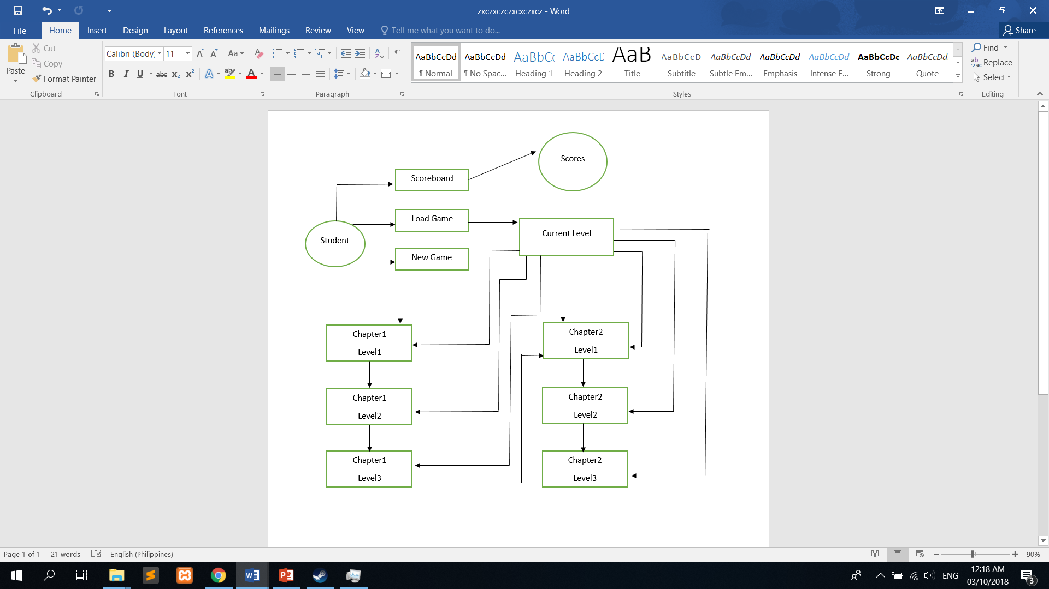

Figure 2: Game Flow Diagram

A student can choose whether to play a New Game or to Load his previous game. After doing so, he/she can now proceed to playing or load his/her previous level.

**Chapters**

1. Chapter 1 – This chapter covers the selection structures of java. The assessments here are all about if, if-else, and switch. There will be lessons taught in every level to help the student finish. There will be enemies that the player must destroy to succeed in each level. In order to finish this chapter, the student must complete each puzzle or assessment in the levels.
2. Chapter 2 – This chapter covers the iteration topic. All the assessments and lessons here are about while loop, do-while loop, and for loop. The same goes for chapter 2, the player must kill all the enemies and answer all assessments correctly in order to finish the chapter and the game itself.

**Levels**

All levels in each chapter will be in the same region as the chapter. But, every level has different lessons and assessments. Each level has 3 assessments that needs to be completed in order to progress through it. These assessments will only be completed if the user inputs the right answer.

**Assessments**

There are 3 assessments per level of each chapter. These assessments are made to challenge the learnings of students. If they apply what they learned here, it will be easy for them to answer.

**Saving and Quitting**

A player can save and quit anytime they want. A player can load their saved game whenever they login. But, if another user creates a new game, the old game of the past user will be lost.

**Chapter 2**

**THE PROPOSAL**

**Statement of the Problem**

The education system of Davao City National High School ICT Program is more on manual teaching by the teachers of the ICT program, they also record student scores and attendance manually. Although most of the teachers are effective in teaching, students tend to show in delay in processing the information they get. They do not absorb lesson right away and they tend to easily forget the teachings given in a day. This delay sometimes causes the students to fail in activities or exercises that the teacher would give. Also, they have limited time in doing hands-on activities because they only go to their labs once or twice a week with 1-2 hours each session.

Below are the specific problems identified by the researchers after conducting series of interviews and studies;

**Checking Student’s Assessment results are time consuming**

Assessments of students are recorded one by one by their own respective teachers. A teacher handles 40 students per class, then, he/she has 3 to 4 classes per day. The ICT head monitors all the assessment done by the teachers for each class. The ICT head goes through all these files to see what topic are they in and what topics are the students good at and bad at. All of these will take a lot of time to finish. The teachers and ICT head will have a hard time finishing them on time. They will have less time preparing for upcoming topics to be taught and for their own necessities. When we interviewed Mr. Sicam before, he was tensed and in a rush. He was trying to finish checking the student’s records before lunch break because it needs to be recorded before lunch. We can only imagine how time-consuming checking of these assessments to the teachers. So, this matter needs to be lessened and managed.

**Student's knowledge is less likely to be retained**

Currently, the school has implemented 2-hour lab sessions. This means that they have less time in laboratories so they cannot apply their learning in the lecture classes completely. 2 hours is not enough to learn and apply a topic discussed in a week. They would need at least 5 to 6 hours of laboratory in order to achieve a milestone in one topic. For instance, Ms. Ornopiataught her students the while loop of java on Monday. The next day is their lab day, so, they are required to apply it to a program. The problem there is that some of his students were not able to complete the task because they did not retain the learnings they got from the lecture because they were not able to apply it while Ms. Ornopia was teaching and demonstrating it to the class. Some students experienced problems in remembering the application and the syntax of the while loop because they did not retain their knowledge.

**Teacher having difficulty in preparing lectures and assessments**

The teachers are tasked to prepare lectures and assessments for their students every meeting. They have to produce something that will give learning to their students. The problem is, they don't have all the time in the world to prepare. Sometimes it is difficult for them because of the time and schedule. They have some priorities to do before preparing and that causes them to lose time for the lectures and assessments that they need to do. For instance, a teacher has a lecture to give the next day but she had to go to the hospital to tend to her sick mother, this might cause her to lose time for the lectures and assessments she has to make. If she cannot produce a lecture or an assessment, students will not learn the topic tasked to be taught in that day. The teachers need some assistance in teaching their students, a supplement that will help them deliver more knowledge and learnings to them like this game which the developers are aiming to create.

**System Objectives**

The researchers aim to create an interactive learning system which includes visual topics and activities, flash cards, interactive quizzes, role playing game(quest-based), and assessments. This application also aims to ignite interest for both the faculty and students of the school.

**Student’s Assessment results are better managed**

Checking of the assessments is very important and is a big responsibility. That is why the developers will make the assessments in the game automatically checked so that it would be less hassle for the teachers. In this game, the teachers will not check the assessments one by one anymore because the game itself will directly show the scores to the students after finishing it.

**There is retention of Student's knowledge**

Student knowledge is very important because it is the basis of almost everything in this program. They will not be passive because this game is going to be developed for pc and the topics while enjoying the game because the lessons are also inside the game itself. This is a good assistance for the teachers because the students will be ready when they have their assessments.

**Effective and Efficient lectures and assessments preparation**

Preparation of lectures and assessments are indeed a hassle thing for teachers, especially when they are busy. They have to provide something that will support the lesson in the lectures. This game is a supplement for the teachings of the teachers. This will give some relief to them because this game will help students understand more about java loop and selection structures.

**Feasibility Study**

**Technical**

The team is developing the game for Desktop PC, so, the game will need fully functional computer in order to run. It needs a desktop pc with a mouse, keyboard, headset, and monitor that is functioning well. As for the software requirements, the game requires at least a computer with 4gb of ram, windows 7 or higher, 3gb HDD space, and video card than can support the game.

**Operational**

The game is intended to help or assist the ICT program of the school so it is clear that the management or the staffs must be ready for the system that the developers are about to develop. The developers are aware that almost everybody knows the functions of a computer and all its components so the developers will just assist them when time comes. The developers will provide

a manual on how the game works for everybody that will use it. Before deploying the game, the developers will provide a demo for all the staffs and students of the said program.

**Economic**

This game is economically feasible because there is no need for the company to purchase a computer unit for it. This game does not require any material from the company for its development. This game also did not require any amount from the company making it economically feasible completely.

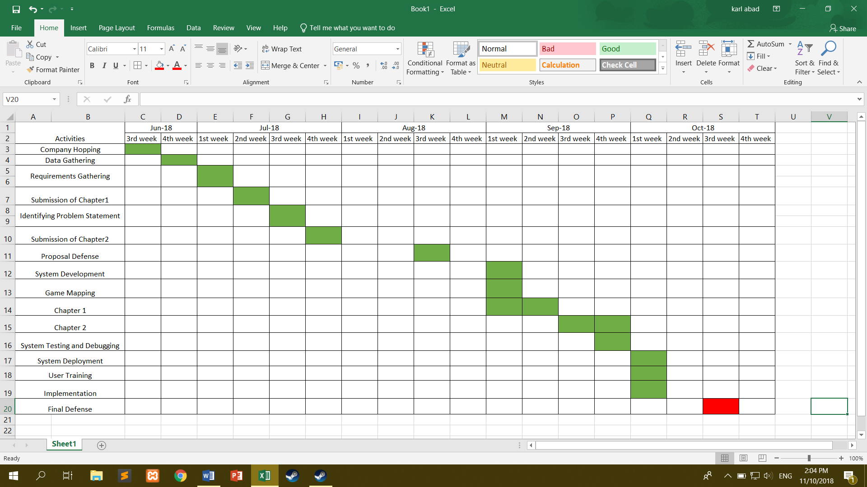**Schedule**

**Figure 3. Schedule**

**Legend:**

* **– Accomplished**

**Chapter 3**

**THE SOLUTION**

**Functional Requirements**

This chapter is all about the functionalities of the game. The topics involved in this chapter are Functional Requirements, Process flow of the game, and the game prototype.

**Main Menu Module**

* Will provide the user the ability to change the graphical options of the game
* The user can view the scoreboard
* Provide the user the ability to start a new game or continue where the user left off

**Game Level Module**

* Action-based game levels.
* Every level has different maps and assessments
* Level 1 and 2 for Chapter 1 are all about the if and if-else statement
* Level 3 for Chapter 1 introduces the switch statement
* Level 1 and 2 for Chapter 2 tackles while loop and do-while loop
* Level 3 for Chapter 2 is about for loop
* Each level has lesson pop-ups to give the user a hint or help them answer the assessments
* Must spawn enemies so that the player can test their abilities
* Show a programming problem for the player to analyze and solve
* Answering an assessment correctly in the first try gives 100 points, -15 every time a wrong output is entered.
* +3 points every enemy killed. -10 points if the user is killed
* Unlocks next level by answering all assessments

**Scoreboard**

* Must show the player name and scores
* The scoreboard stores the score of the players who finished the game
* Scores of all user of the computer will be shown in the scoreboard in the main menu

**Process Flow**

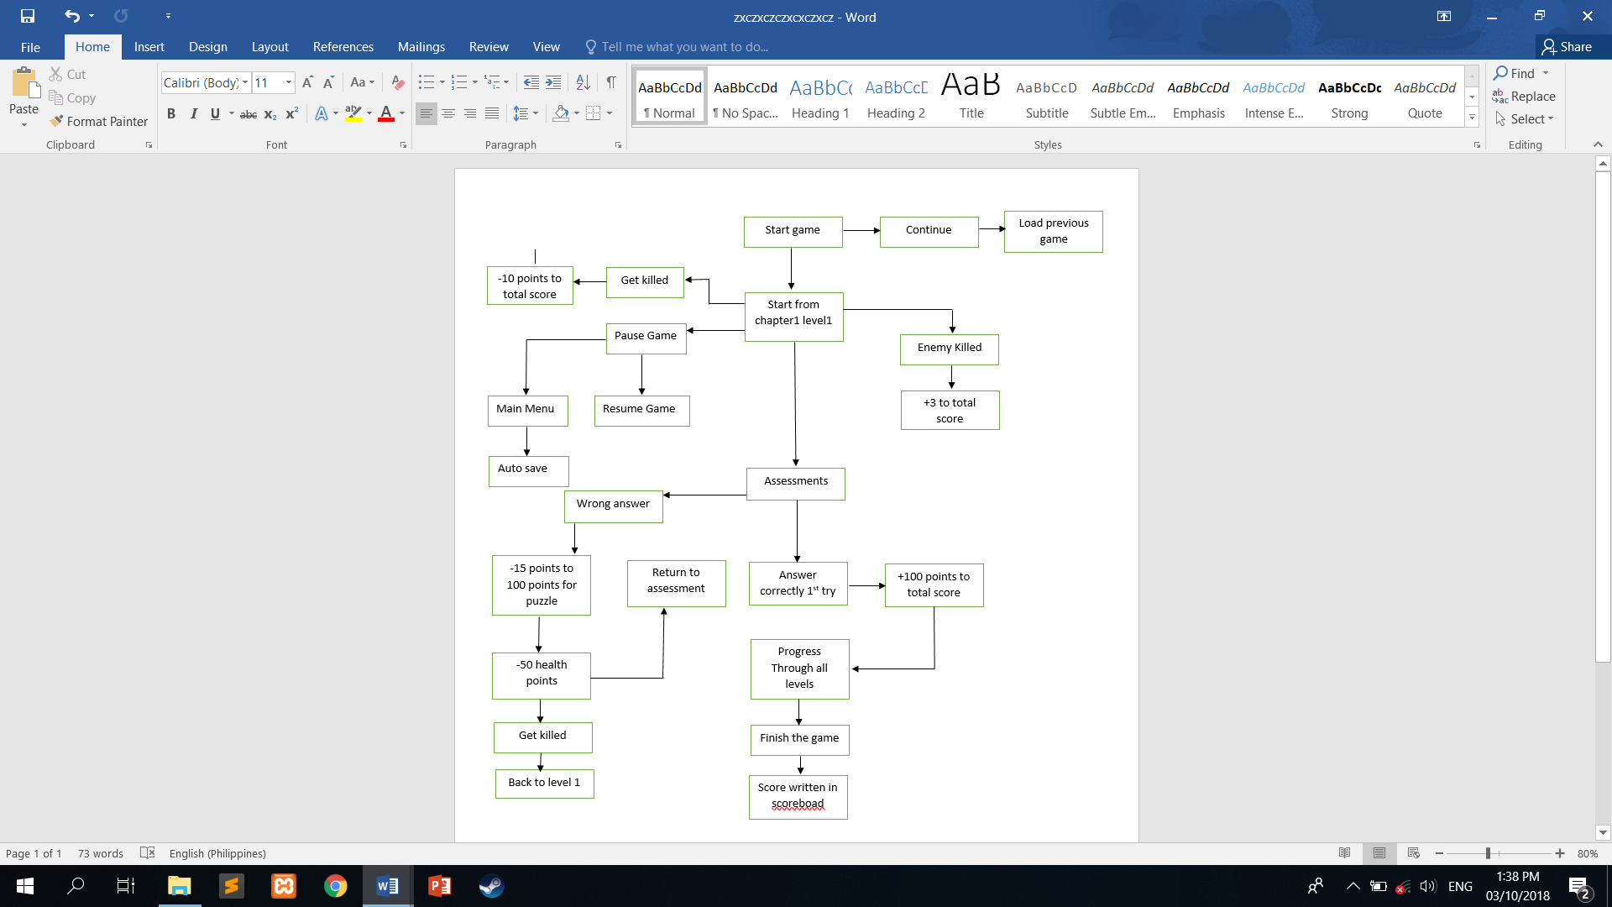

Figure 4. Process flow

**Game Prototype**

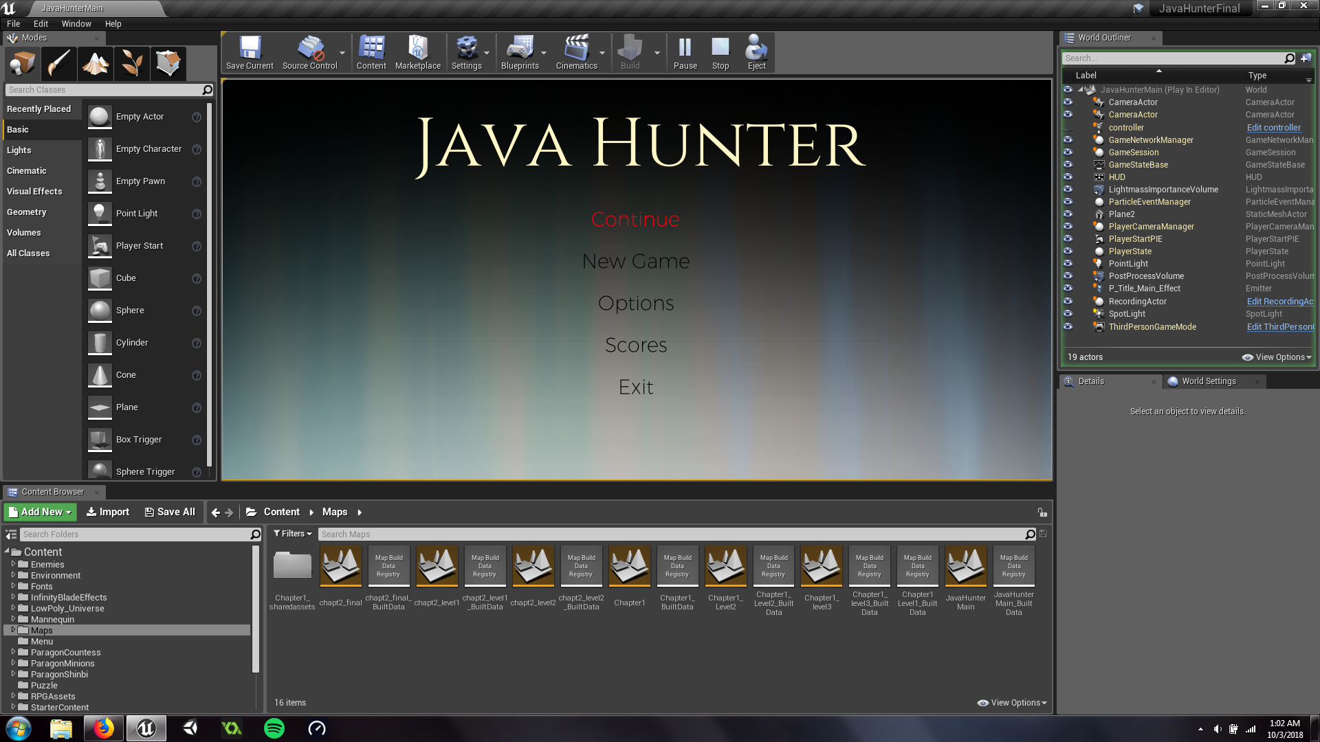

Figure 5. Main Menu

This is the main menu of the game. It is where the options for the game and settings are located. Also, the scoreboard is located here.

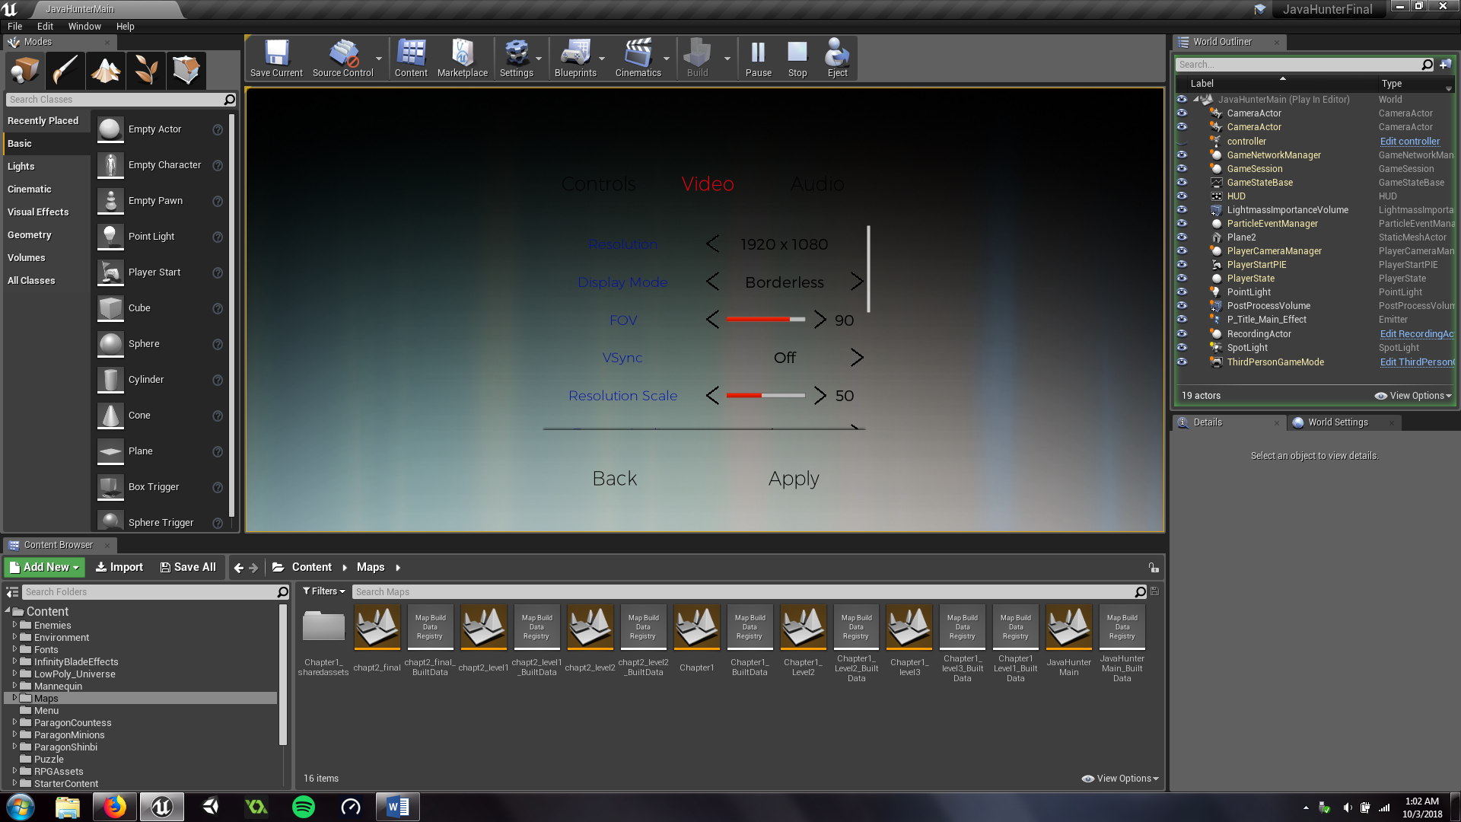

Figure 6. Setting

This the interface where the user can change the video settings. He/she change it if his/her computer is slow or fast.

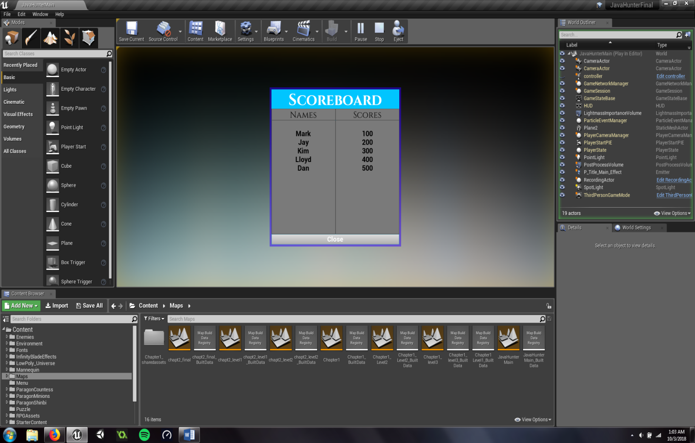

Figure 7. Scoreboard

This is the scoreboard. The scores of the users who finished the game will be saved here. All users of the computer can see the records here.

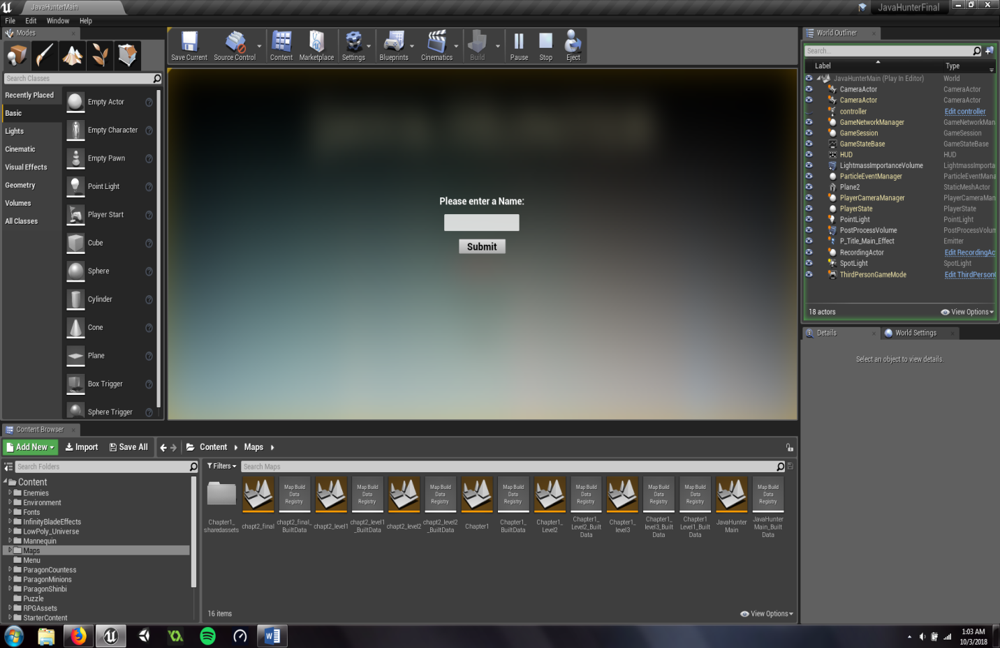

Figure 8. New game

This is the interface shown when the user starts a new game. He/she will be asked to input his/her name.

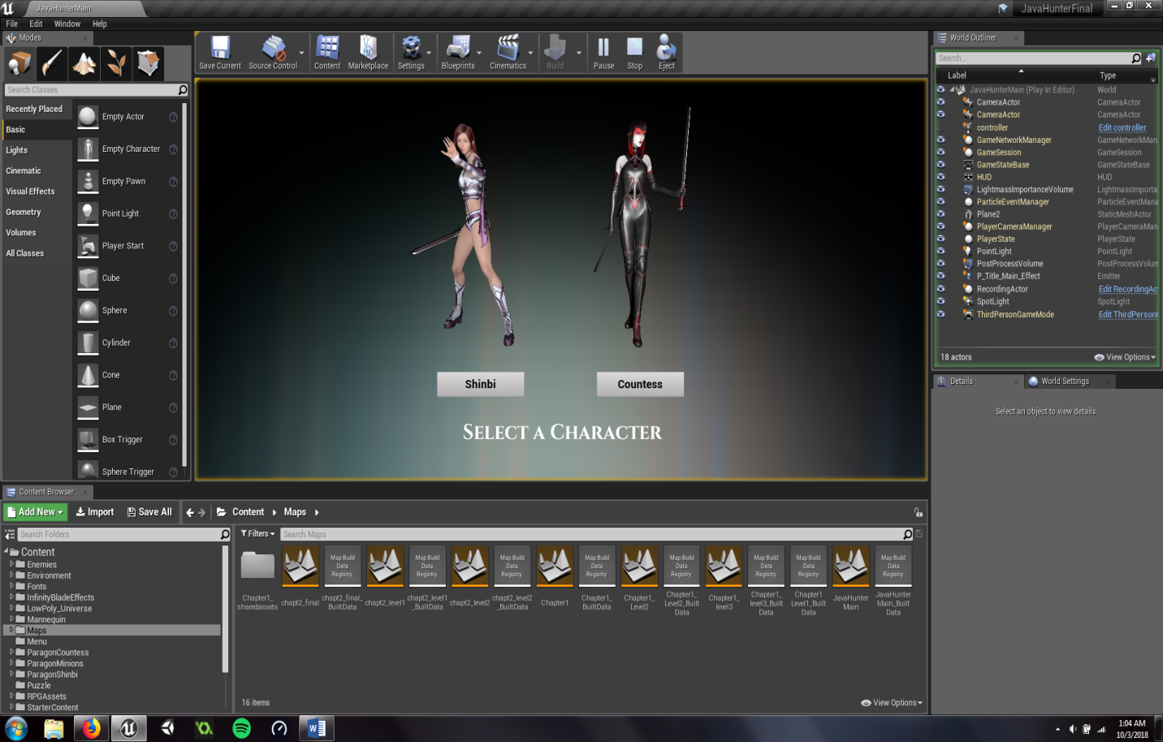

Figure 9. Character Selection

This is where the user selects the character of his/her own choice. There are two characters to choose from. Shinbi and Countess. They have different abilities.

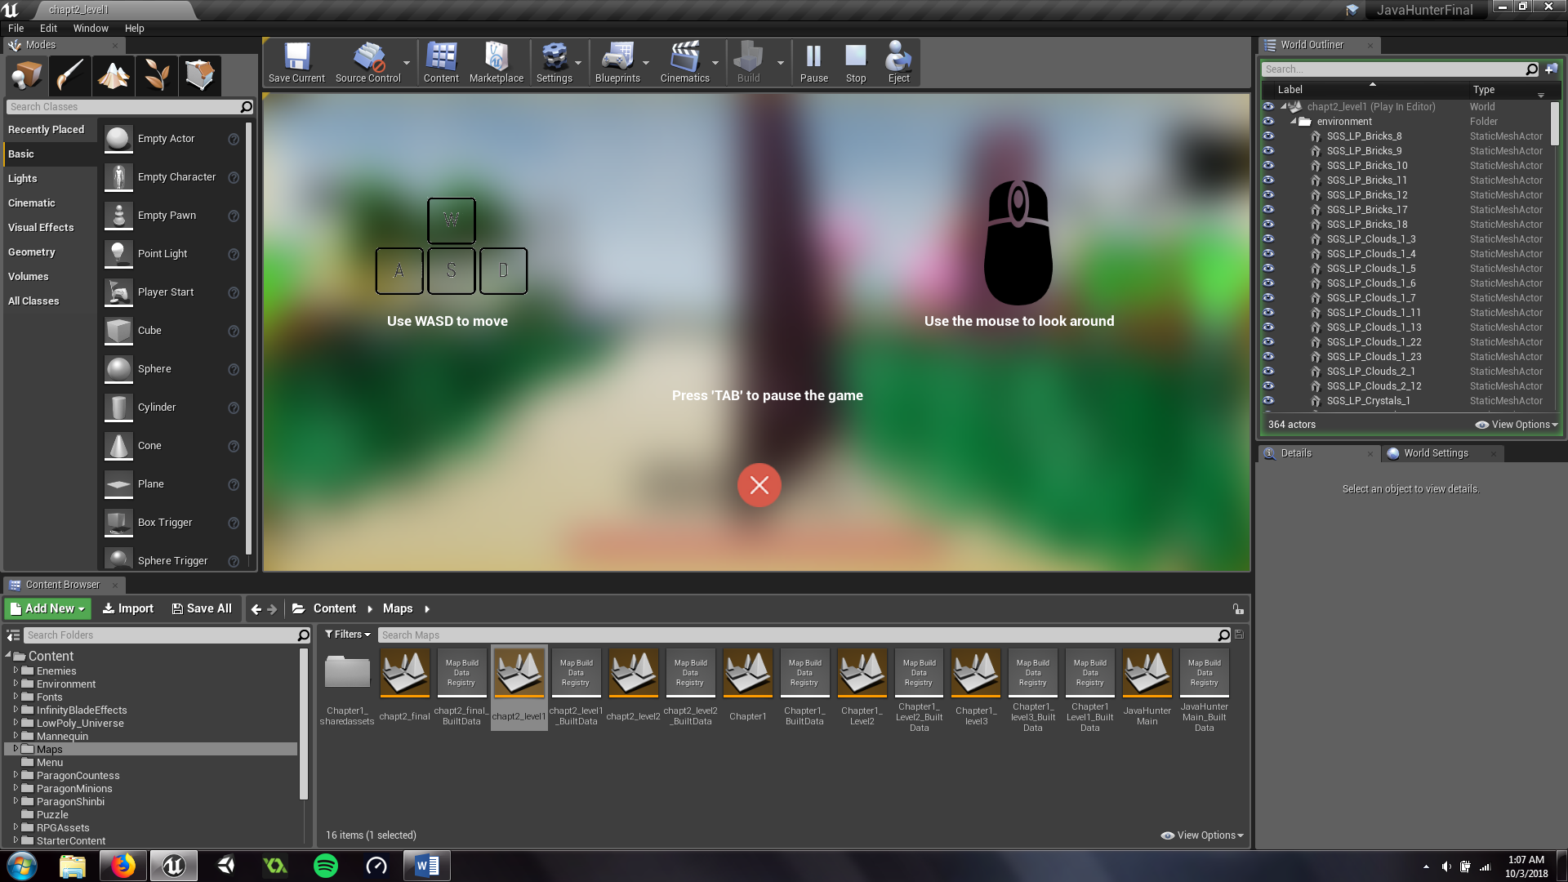

Figure 10. Instructions

Introduction of controls and basic ideas of the game to the player/user. Basically instructions on how to controll the characters.

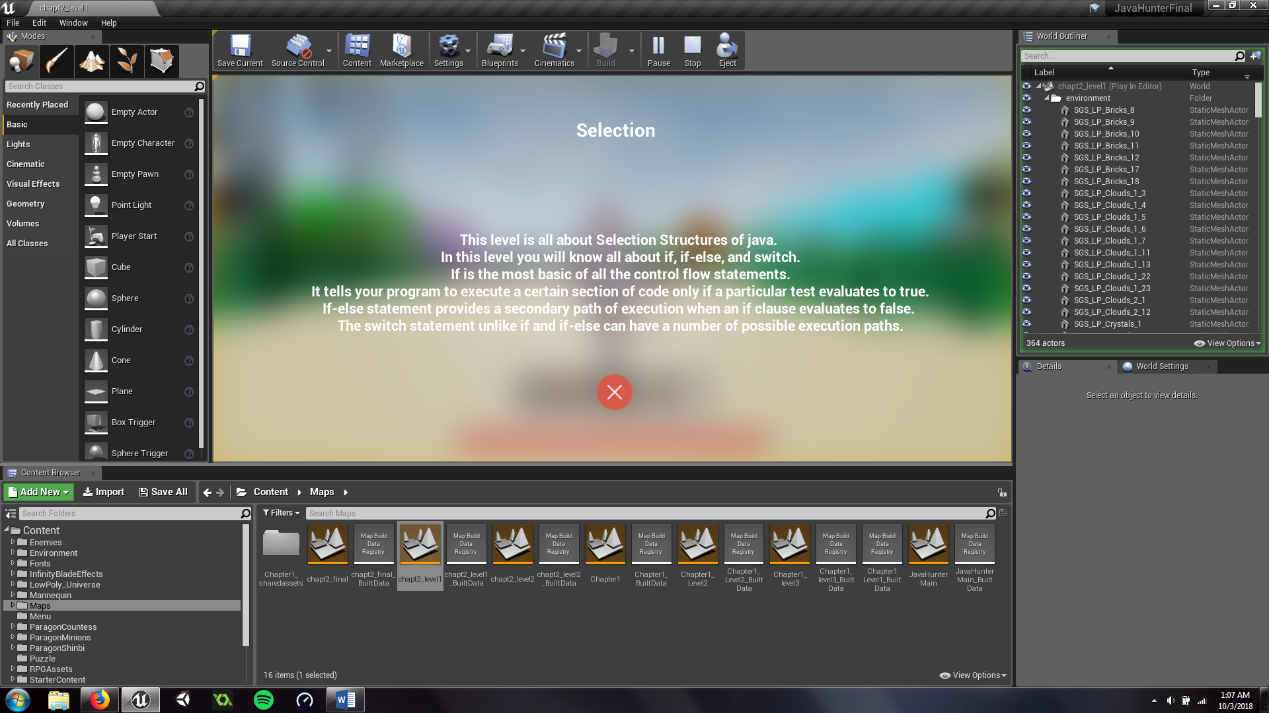

Figure 11. Pop-up Lessons

Lesson pop-ups to help users get the idea of the topics being taught. This will help them prepare for the assessments in every level.

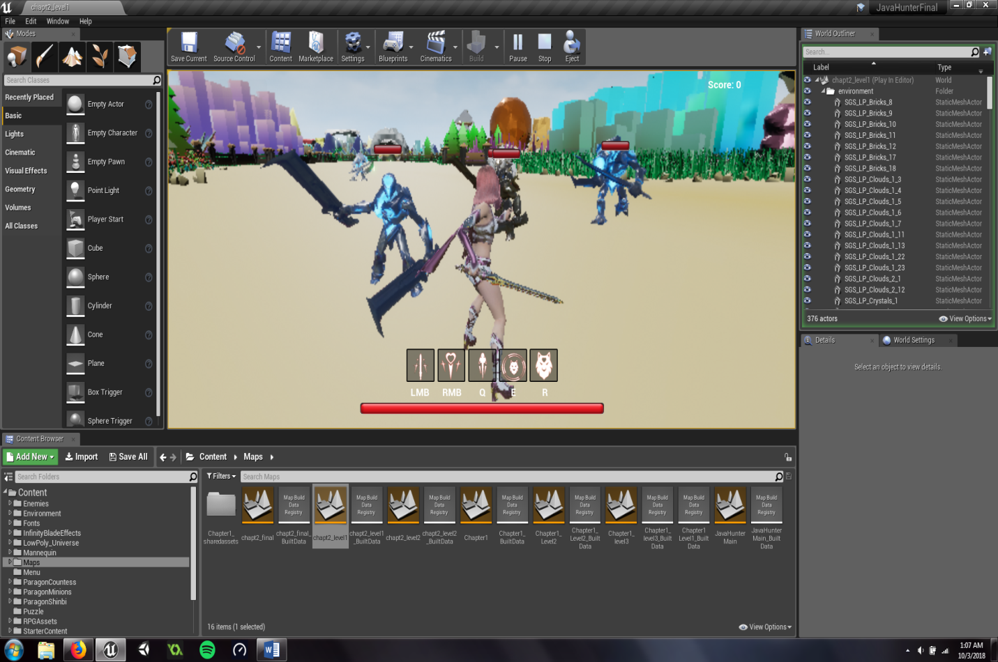

Figure 12. Enemy Spawn

Enemy spawns are scattered all around the maps. These enemies should be killed in order to progress through the level.

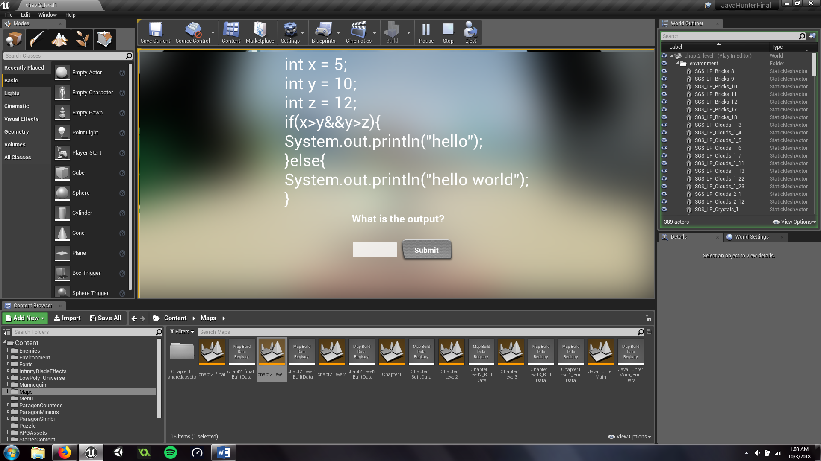

Figure 13. Assessment/Puzzle

This is the assessment widget for the users to answer. They cannot advance to the next island or level if they cannot answer correctly.

**Chapter 4**

**THE IMPLEMENTATION**

**User Acceptance Training**

The researchers conducted a user acceptance training in DCNHS. A demo was the first approach for the user training. The demo was intended to let the students and the teacher know how the game works. How it opens, how to change the settings, how to load and save, and all the components. Its goal is to give them ideas so that they can catch up fast when the real process of user training starts.

After the demo is done, the developers started the training. The users were instructed what to do and what to expect. After a successful launch of the game, the users already knew what to do. Because of this, the user training was a success and there were no problems at all.

The researchers gave the future users step by step instructions in the demo;

* Start the game
* New Game/ Continue
* Choose character
* Kill enemies
* Read pop-up lessons
* Answer correctly the assessments

The researchers gave instructions on the game mechanics. The students were given awareness about the scoring system and the deductions. They were taught that every wrong answer gives -15 points to the possible 100 points given for answering the assessment. They were aware that 3 points are given if they kill an enemy and -10 points every time they get killed. The researchers also warned them that if they die they will go back to the start of the level.

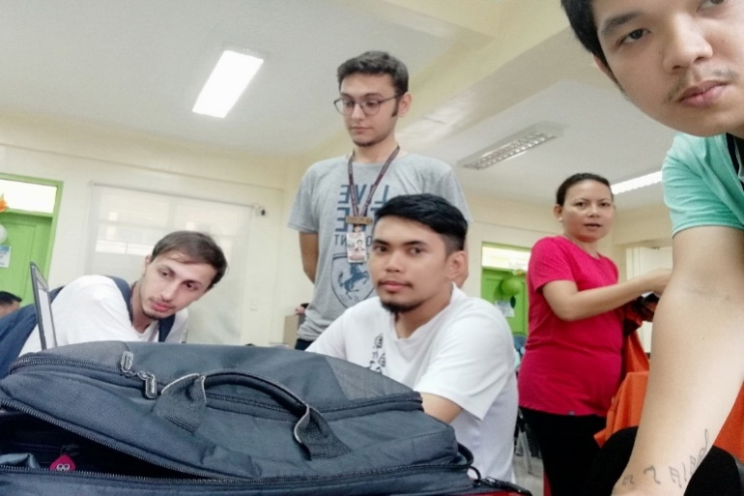

Figure 14. Discussion with the teacher

The team discussed with ma’am Ornopia for the user training to be conducted. The team discussed all the necessary information about the game and how it works.

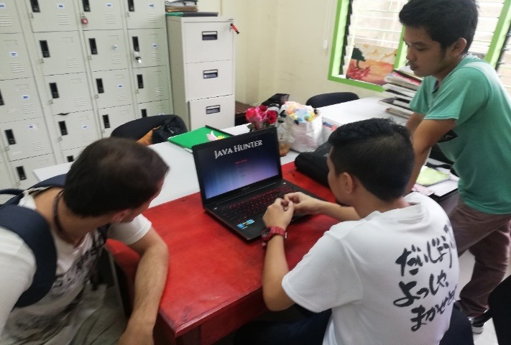

Figure 15. Showing of game functionality

The team showed the functionalities of the game to the head of the programming department and introduced to her what are the additions of the developers since the last company visit.

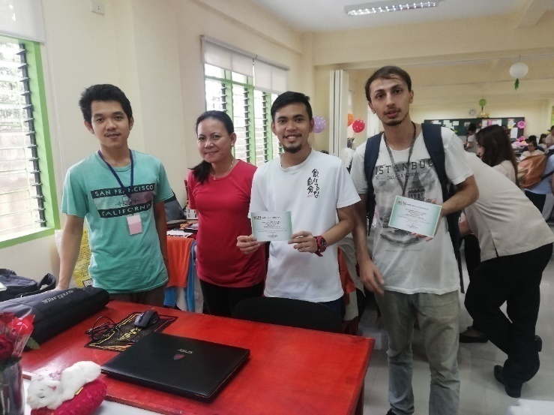

Figure 16. Successful user training

After all the process done, the game was introduced successfully to the users.

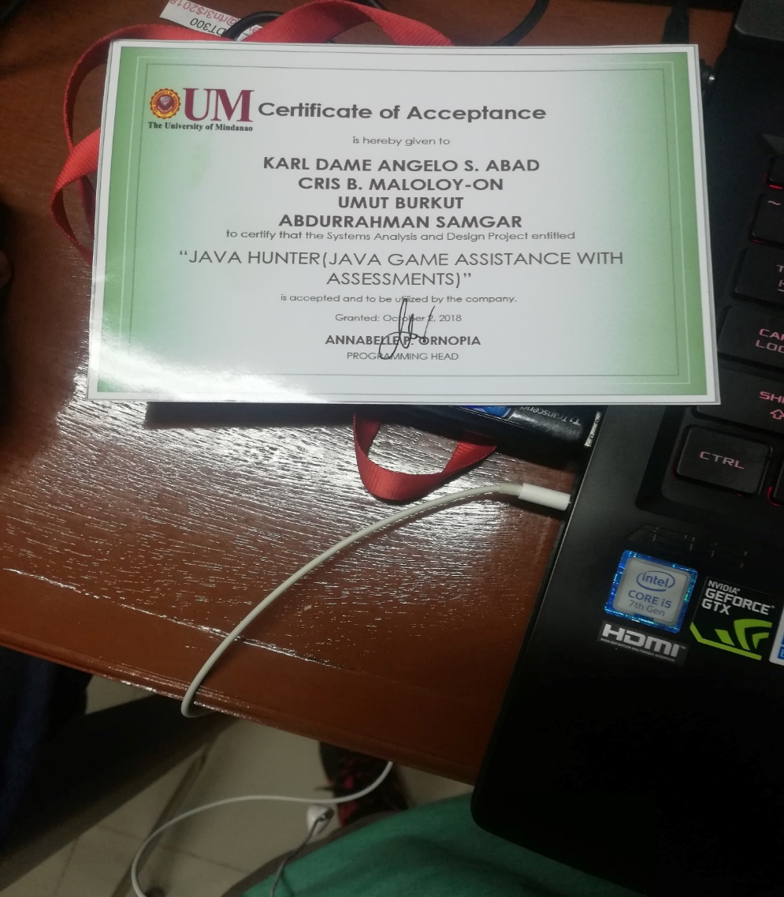

Figure 17. Certificate of acceptance

After the user training conducted, the certificate of acceptance was signed by the programming head.

**Deployment Plan**

During deployment, the researchers used multiple flash drives to duplicate the game into their computers in the programming lab. After supplying each computer with the game, the developers tried to run it in order to see if there were errors in copying the game. After checking, everything turned out right and correct.

After copying the game into their system, the researchers tried to see if the game was running properly or does the graphic settings needs to be lowered. After a successful error check, the game was successfully deployed and ready for user training.

There were 20 students present when the researchers conducted the deployment. 15 played the game because some of them chose not to because they were busy in the time of deployment. The teacher stated that liked the game and it is a big game. The students enjoyed it but they find it challenging also.

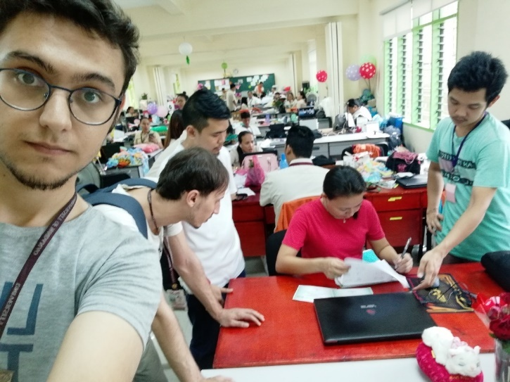

Figure 18. Deployment Planning

The team went to the faculty room in order to discuss with ma’am Ornopia about the game and to show that it is ready for deployment.

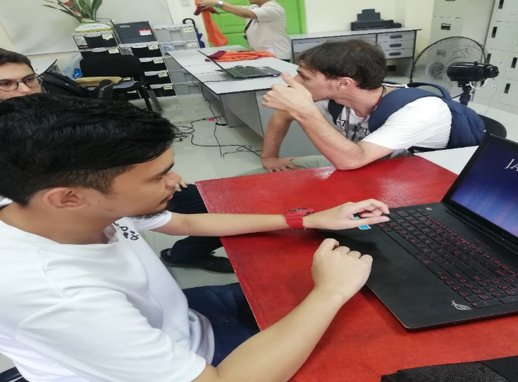

Figure 19. Deployment

After the brief discussion, everything was set. The team installed the game on the computers in their laboratory.

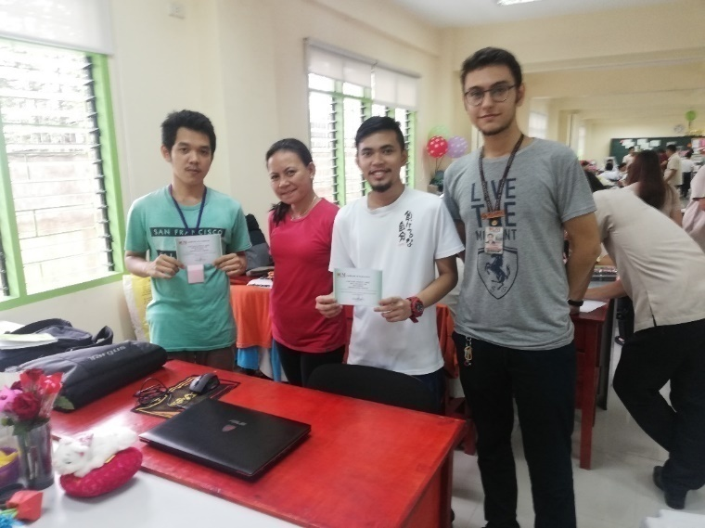

Figure 20. Successful Deployment

The deployment was successful and fast. There were no problems encountered and the game was fully functional.

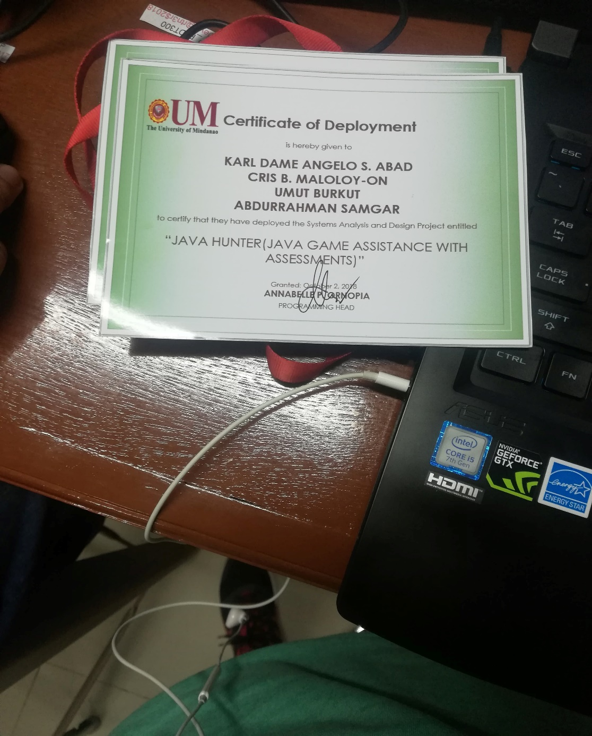

Figure 21. Certificate of Deployment

After all the process for deployment of the game to their computers/system. The certificate of deployment was signed by the programming head and it was a successful deployment.

**User’s Manual**

This game is designed for students who wants to learn java concepts. The user will learn and solve problems based on java selection and iterations concept. When starting the game, the user will have to enter a name to attach the score you get.

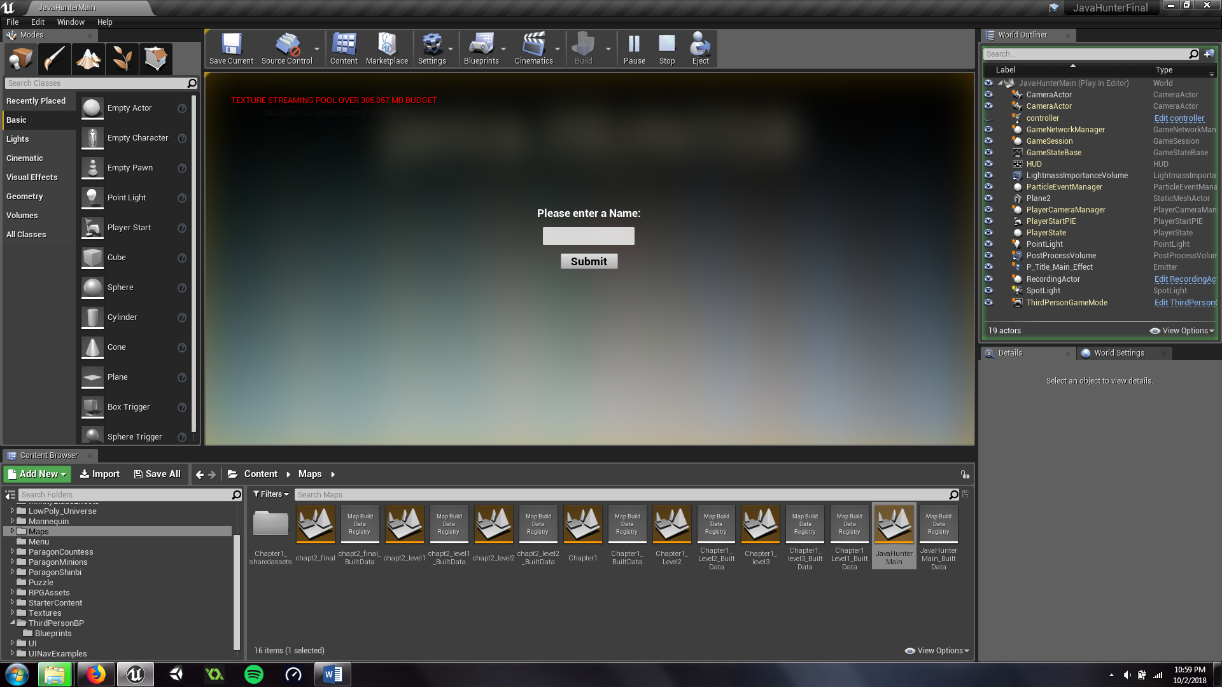

Figure 22. New Game Manual

The user will then be able to select one of the two characters namely countess and shinbi.

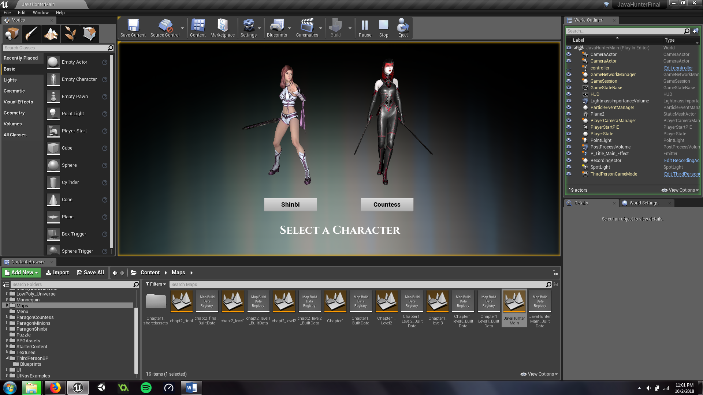

Figure 23. Character Selection Manual

Countess focuses on burst damage while Shinbi focuses on damage over time.

Pressing the left mouse button will make the character attack. You can string this attack 3 times before resetting back to the first attack.

You can use skills with the right mouse button, Q, E, R. These skills however have a cool-down where you can’t use the same skill again until the cool-down is finished so you can’t just spam it.

The right mouse button is a dash skill and using it will push the character forward. It also has the lowest cool-down of all the skills.

The R ability has the longest cool-down of all the abilities but has the most damage.

After selecting a character, you will be prompted with the tutorial for the game. After progressing a little bit, the game will display lessons, hints or examples for the topic of the level. On some part of the map, you’ll trigger a problem where you have to solve it or you’ll lose some health and some points.

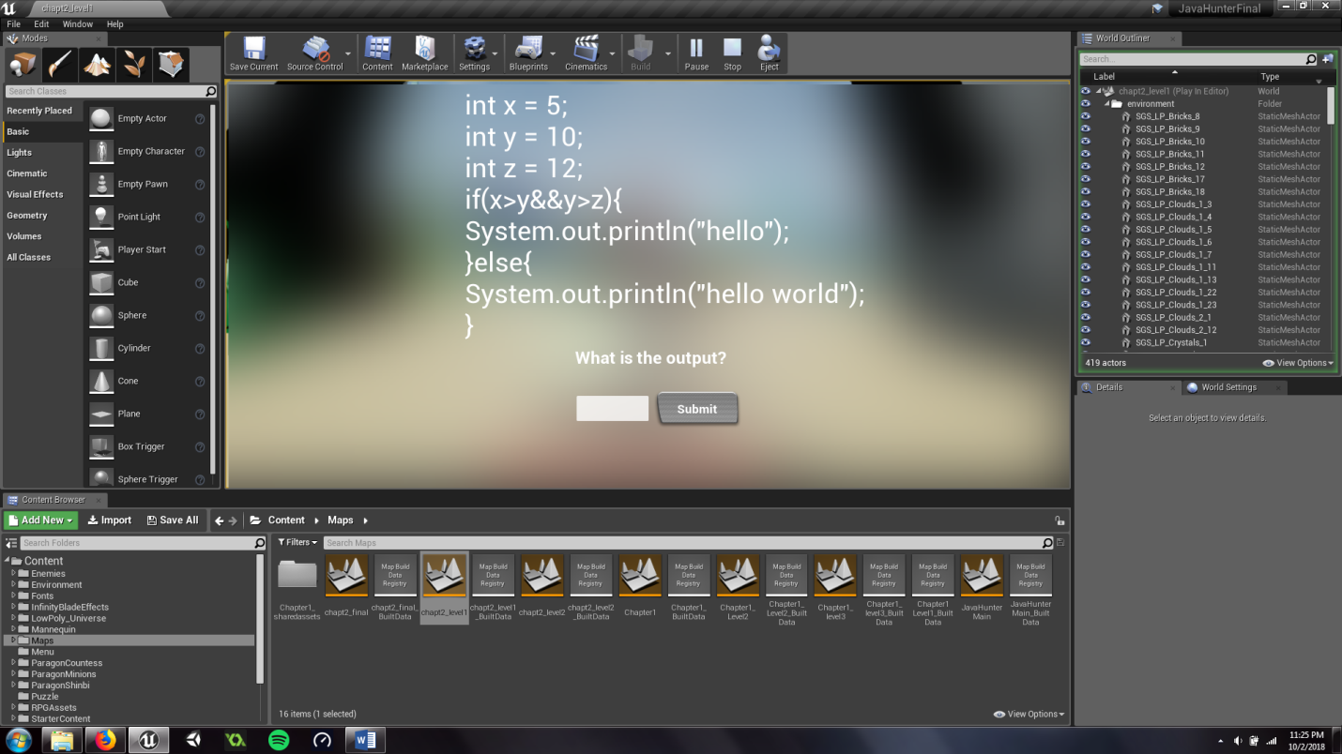

Figure 24. Assessments Manual

Each level will have 3 separate problems and after solving the final problem of that level you’ll proceed to the next level. Do this for the three times to complete the chapter. There are 2 chapters and 3 levels each. After finishing all the chapters and levels, you’ll go back to the main menu and your score and name will be posted to the scoreboard which you can view in the main menu item called scoreboard.